LGM Specification: CPPE Algebra for Pipeline Stream Action
The Contextual Prime Product Embedding (CPPE) algebra treats every node in the graph not as a string or a pointer, but as a unique prime number. By leveraging the Fundamental Theorem of Arithmetic, relationships and sets are represented as products. This allows the Reactive Stream Pipeline to perform complex graph "joins" and "path traversals" using simple CPU-native arithmetic.

1. Algebraic Definitions
Let 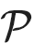 be the set of unique Prime IDs assigned to URIs.
For any ContextPoint :
- 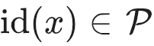 (The singleton identity).
- 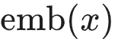 (The cumulative embedding).

The Prime Product Rule
The embedding of a triadic occurrence 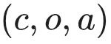—where is Context, is Object, and is Attribute—is defined as the product of their respective recursive embeddings:

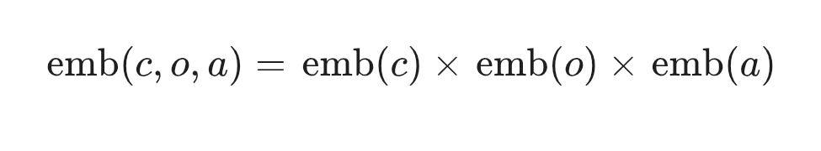Because every factor is a prime (or a product of primes), the result is a unique "coordinate" in the integer space that encodes the entire lineage of the relationship.

2. Pipeline Stream Operators (The CPPE Monad)
In a reactive stream (e.g., Flux<ContextPoint>), the following algebraic operators are used for "Stream Action":

A. The "Contains" Operator (Sub-graph Filtering)
To check if a stream of Objects belongs to a certain Context 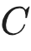 or possesses an Attribute 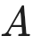:
- Logic:
- Reactive Implementation:
// Filter objects that are part of the 'Accounting' context
objectStream.filter(obj -> obj.getPrimeIDEmbedding().remainder(accountingID).equals(BigInteger.ZERO));

B. The "Intersection" Operator (Aggregation)
To find commonalities between two streams (finding the "Type" or "Concept"):
- Logic:
- Stream Action: The Greatest Common Divisor (GCD) of the embeddings of two nodes represents their shared FCA attributes/contexts.
- Aggregation Use Case: When the stream encounters multiple SPO triples, it calculates the "running GCD" of the attributes to infer the Schema (the most specific common super-type).

C. The "Axis Shift" Operator (Alignment)
Alignment predicts a value for a new context by calculating the "Ratio" of change between existing embeddings.
- Logic:
- Stream Action: By dividing by the "Old Axis" prime and multiplying by the "New Axis" prime, we re-project the object into a new coordinate.

3. Pipeline Stages Revisited via CPPE

3.1 Aggregation (Algebraic Type Inference)
The Aggregation pipeline consumes raw SPO streams and produces "Type Tensors".
- Input: Stream of rotated triples 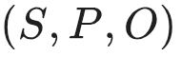.
- Action: For all sharing attribute , calculate the product 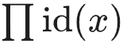.
- Inference: If  is divisible by the product of a set of attribute primes, is classified into that Type.
- Complexity: 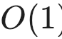 lookup via modulo instead of 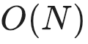 graph search.

3.2 Alignment (Vector/Prime Space Prediction)
Alignment uses the Prime Ratio to detect structural similarity.
- Input: Aggregated Types.
- Action: Map the distance between objects 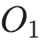 and 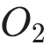 as 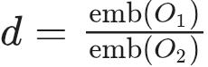.
- Discovery: If 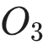 and 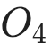 share the same ratio , the system aligns them as being "analogous" in different contexts (e.g., "CEO is to Company A what Principal is to School B").

3.3 Activation (State Transition Product)
Activation is the "Activation Energy" required to move from one prime state to another.
- Transition Formula:
- Monadic Wrap: The Occurrence Monad captures the prime state of an actor. When the stream processes a "Role" event, it multiplies the actor's prime ID by the role's prime ID.
- Trigger: If the resulting product matches a known "Success Pattern" (a pre-calculated product of requirements), the Activation is fired (e.g., triggering a webhook or a UI change).

4. Summary Table of Algebraic Mappings
Graph Concept | CPPE Algebraic Operation | Stream Performance
Node Identity | Unique Prime Assignment | 
Edge/Relationship | Multiplication of Primes | 
Path Traversal | Division / Modulo | 
Common Ancestor | Greatest Common Divisor (GCD) | 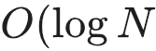
Graph Join | Least Common Multiple (LCM) | 
Hierarchy Level | Prime Factor Count (Omega function) | 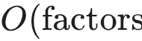

5. Implementation Notes for the IO Monad
The IO Monad wrapping these operations ensures that prime ID generation is sequential and thread-safe. As triples flow through the reactive pipeline, the Monad carries the "Arithmetic State," allowing the system to handle millions of triples per second by avoiding expensive pointer-chasing in memory and replacing it with high-speed integer math.

